Strategy,

Grade each stock as trending or not (1 yes, 0 No)

How to grade will be based on how each of the following indicators are behaving:

ADX

RSI

Moving Average

Bollinger

Will look at slopes of each, whether they are making higher highs or lower lows, where price is relative to each, stage of trend (only trade early stages? Or retracement?) etc.

Will create a function for each indicator that will provide a 1 or 0. If 3 of the 4 are aligned, enter trade. Will use same criteria to exit trade.

Will trade off of 60 minute chart (entry/exit trading signals come from here) – then align with daily for primary trend, and 15 min for short term trend. Timeframe analysis to be built in to indicator functions (i.e. adx needs to be making higher highs on 60 min and daily, but maybe retracing on the 15minute for a good entry/exit).

Using 14 period lookbacks for adx, rsi, and Bollinger (2 standard deviations). Use 10 period Simple Moving average only

Need to build logic for events that disrupts potential trend (big candlestick on big volume or big vol move that indicates news etc.) These would be exit signals.

The details of the trading and the overall market understanding, both are what you need

Guide:

The ability of the trading professionals to judge the overall situation and details of the market is far from comparable. Before the trading, he will pay attention to the following aspects of the market and clearly give the answer:

(1) Is the current market environment suitable for operation? Is there a trend in the market? If there is no trend, what kind of form is the market likely to be building? Is it a bottom reversal pattern, a top reversal pattern, a trend relay pattern, or a temporary disorientation to be observed? Where is the important support or barrier level?

(2) If there is a trend, what level is the trend? Is the bull market or a bear market? Early, mid or late in a bull or bear market? If it is a secondary reentry trend, which position has it retreated to the length of the previous trend? 33%, 50% or 66%? What is the status of the daily, weekly and monthly chart? What is the relationship between market long-term, middle-term and short-term trends?

(3) Is there a symbolic K-line, resonance, anti-vibration, over-head signal on the daily, weekly, and monthly K line graphs? If so, what kind of market is indicated? Are there any important technical phenomena such as gaps, single-day/single-week/single-month reversal, over-ups, over-slipping?

(4) Is the market in a normal state of advancement or an extreme state? Does the volume (position) verify the price change?

This is the overall situation, that is, the overall judgment of the trader on the macro and micro position of the market, the long-term and short-term direction of the market. Traders derive from this judgment the long-term and short-term bullish or bearish conclusions of the market and act accordingly. Normally, professional traders only enter the market when the market's long-term and short-term movements are in the same direction. If the market is not consistent in the long-term and short-term direction, he will either not trade or engage in short-term trading. Before actually entering the game, he will also clarify the following questions:

(1) How will the market evolve the most from week to month?

(2) If you decide to wait and see, how long does it take to wait and see? If you decide to enter the market, the amount of position that you will hold for buying-long or selling-short?

(3) At what exact point that you want to jump in? Where is the profit target?

(4) What kind of trading system are used to enter the market? Where is the protective stop loss order placed?

(5) If I make a mistake, how much risk do I intend to take?

**8 Indicators, Tips And Tools To Read Trend Strength In Trading**

Trading is all about being able to read market structure, sentiment and the balance between bulls and bears. **Understanding if a trend is gaining or losing momentum is important** if you are trying to make decisions about whether support and resistance levels are likely to hold or break, if a trend will continue, or if a reversal can be expected anytime soon.

In a different article, we talked about [how to understand the direction of a trend](https://www.tradeciety.com/how-to-know-direction-of-the-trend/); this article explains how to read the trend strength from your charts. The following 6 concepts, tools and indicators can help you make sense of price action and provide insights about market structure.

**1) Price action analysis**

**Trend waves – length, steepness, and smoothness**

The first point lays the groundwork for all that follows and it describes the basics of price movement. The way price moves during trending waves and pullbacks can tell you a lot. The chart below shows a downtrend with a series of lower lows. At the same time, you can see that the bearish price waves are much **smoother** and the bullish pullbacks are less smooth.

Secondly, the **steepness** of the bearish price waves decreases and they become **shallower** as the trend continues. Steep price waves indicate trend strength whereas **shallow** price waves signal a lack of strength. Also, **the size of the trend-waves** is important to understand. The chart below shows that the bearish trend-waves become smaller.

The blue circled area highlights the first period bears **faced strong opposition** and price wasn’t able to move further down as smooth. This price behavior is in sharp contrast to previous price action. In a strong and healthy downtrend, the bearish trend-waves do occur mainly uninterrupted.

[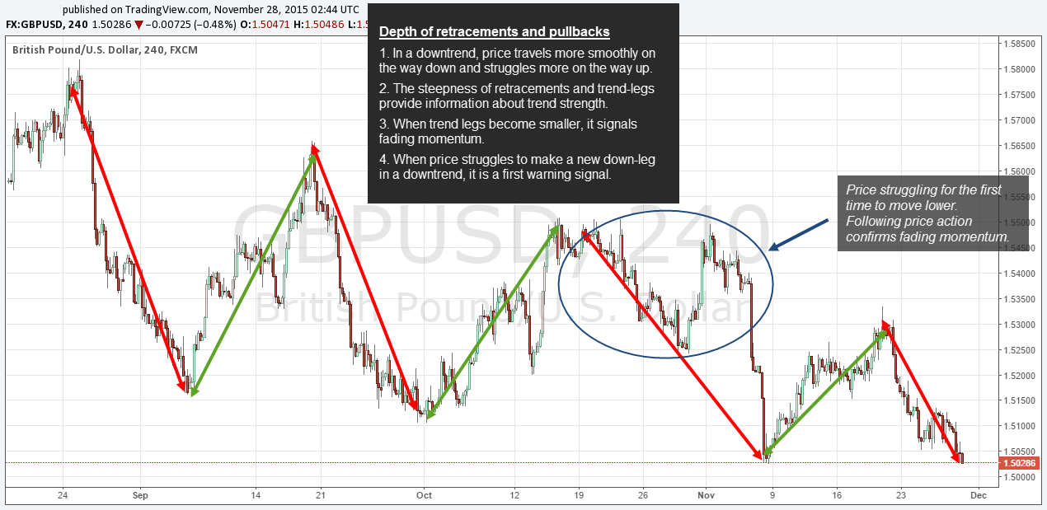](https://www.tradeciety.com/wp-content/uploads/1-depth_1.png)

**Pullbacks during a trend**

The next screenshot highlights the importance of putting **the size of pullbacks** into context:

* The first green shaded area shows the first larger pullback during the ongoing downtrend.
* Before that, the pullbacks were relatively small which signaled strong momentum to the downside. Often, strong trends only show sideways ranges instead of real pullbacks.
* A large pullback can foreshadow a broken market structure and it provides first indications of losing trend strength.
* Finally, price failed to make lower lows altogether which had been foreshadowed by the increasing size of pullbacks against the downtrend

**2) The slope of trendlines**

[Trendlines are a great trading tool](https://www.tradeciety.com/how-to-use-trendlines/) because they provide instant information about the strength of a trend. First, you have to pay attention **to the angle of a trendline** because the angle shows you exactly how strong the trend is. In an uptrend, a small angle means that the new lows are not moving up as fast. However, once the angle becomes too large, it often signals a trend (Boom) which is not sustainable.

[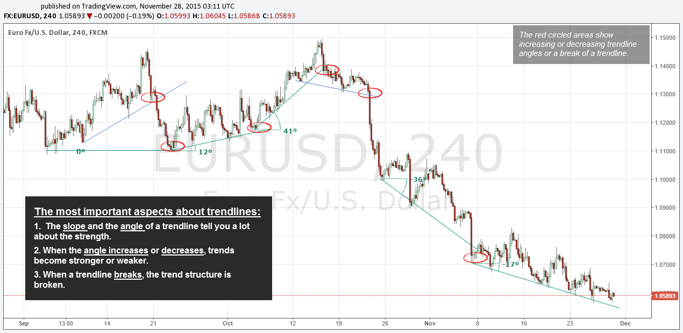](https://www.tradeciety.com/wp-content/uploads/3_trendline.png)

**An increase in the angle of trendlines** means that price is gaining momentum and price is making higher highs faster.  Finally, **a break of a trendline** signals a broken market structure. A break can either mean a decrease in the momentum of a trend or a complete trend reversal.

* The slope of trendlines describe trend strength
* An increasing slope in an uptrend shows a trend with rising momentum
* A decreasing slope shows fading momentum
* The break of a trendline is the final signal of a trend reversal

**3) Bulls vs. Bear and microstructures**

We already touched on this topic when we talked about pullbacks earlier but there are a few more things that we can use to our advantage when it comes to analyzing the dynamics between bulls and bears during trending phases. There are a few things a trader needs to be aware of when analyzing a trend and tries to estimate the strength:

* A trend where **candle bodies do not overlap** signals strong strength because price keeps going in one direction without pulling back significantly
* When candlesticks show **no or only small wicks**, it also signals a strong and healthy trend
* Candlesticks are roughly **the same size and are not too large**. If you see that suddenly candlesticks are becoming very large, it means that volatility is increasing. This often happens when markets approach a top or a bottom
* If you see gaps, especially in the daily timeframe, those gaps don’t close and price keeps trending

[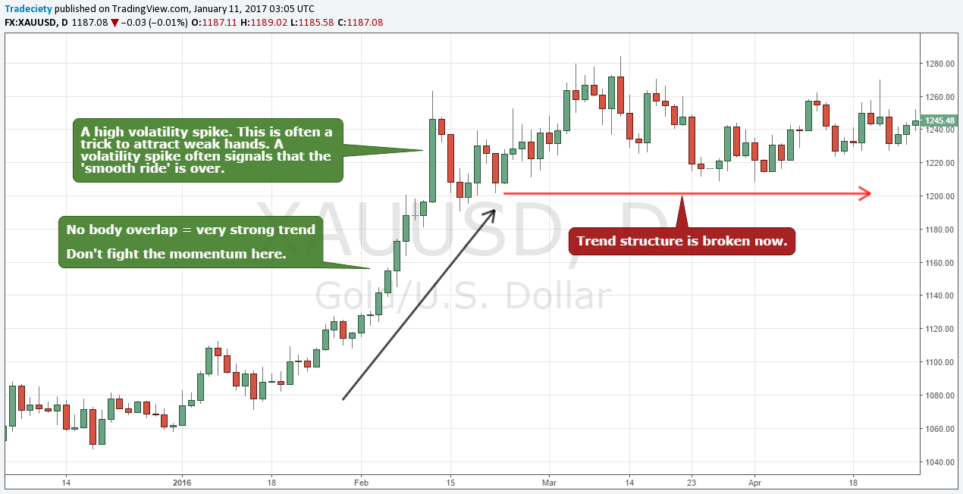](https://www.tradeciety.com/wp-content/uploads/micro-structure.png)

**4) Rejected reversals**

The way failed breakouts and rejected reversals occur on your charts is a big tell as well. Here are the most important patterns and characteristics when it comes to analyzing failed reversals during trends:

* Price does not overshoot trendlines or when it does, it never closes beyond a trendline
* When a trendline breaks, there is only a sideways move and no immediate reversal
* Reversal spikes get immediately rejected and covered
* Pullbacks into moving averages are very quick and price does not stay long at a moving average

[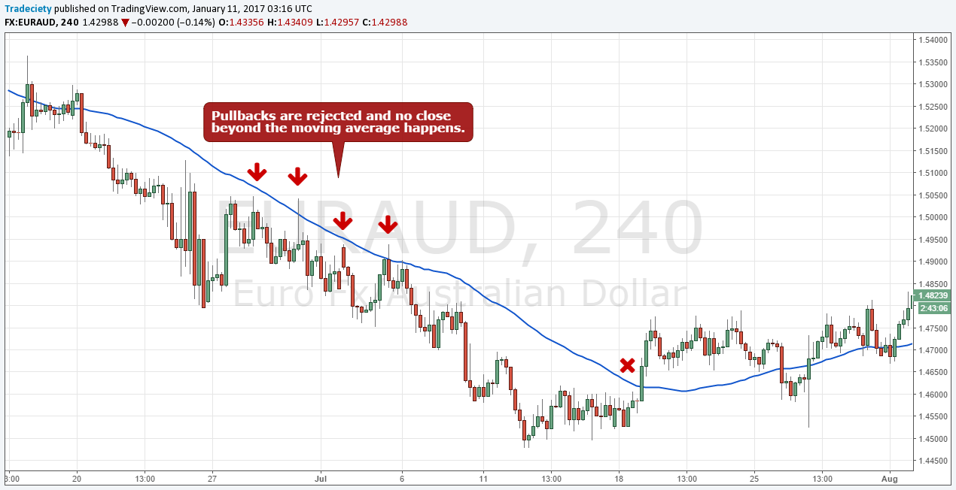](https://www.tradeciety.com/wp-content/uploads/rejections.png)

**5) ADX**

[The ADX measures trend strength](https://www.tradeciety.com/tips-to-use-the-adx-indicator/) and it is non-directional which means that it cannot tell you which direction price is going – **it only tells you if the trend is gaining or losing momentum**.

The chart below shows a downtrend and the first down-movement shows a lot of strength in the ADX by making a new high and absolute on the ADX. The next two bearish moves were much smaller and not as strong and the ADX confirmed it by showing lower highs. The last move on the far right showed a very choppy and narrow movement and the ADX went dipped at that point, the price had entered a range.

[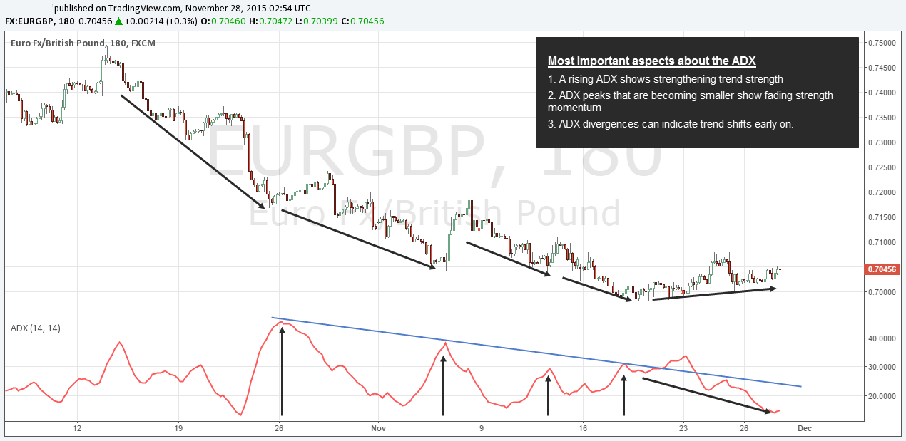](https://www.tradeciety.com/wp-content/uploads/4_ADX.png)

* A rising ADX shows gaining trend strength
* New highs on the ADX signal a healthy trend (Erik Add – take max of all highs over some look back period, maybe 14 periods, and then see if the max high happened recently, maybe in the last 5 periods)
* Lower highs on the ADX signal losing strength
* A “hook” on the ADX shows a sudden shift in trend strength
* A flat or an ADX heading down signals a range

**6) Moving averages (MA)**

**The relation of price to the MA and the slope**

Moving averages are a great trading tool because they provide a variety of different information at once. First, **the slope of a moving average** is important. When the price is above the MA and the MA is moving up it signals a strong trend with prices rising faster than the historical averages. **The further price can pull away from a moving average, the stronger the current trend is.**The longer price can stay on one side of the moving average without touching the moving average, the stronger the trend.

**The MA crossover – sentiment shifts**

**The combination of a smaller and a larger moving average** measures sentiment shifts in price. The screenshot below shows a chart with a 50 and a 100 MA. When **the small MA crossed above the larger MA** it signaled a shift in sentiment to the upside because recent prices were moving above the average of the longer term price structure. Conversely, when the shorter MA crossed the larger MA it signaled a sentiment change to the downside because recent price started trading below the longer-term average.

**The space between MAs – momentum information**

Finally, the bigger **the space between the two MAs**, the stronger the trend is becoming because the recent price is pulling away from the long-term average faster. The size of space between the two MAs provides information about momentum. The MACD or the Ichimoku indicators are both based on the differences between short term and long term average price structure.

[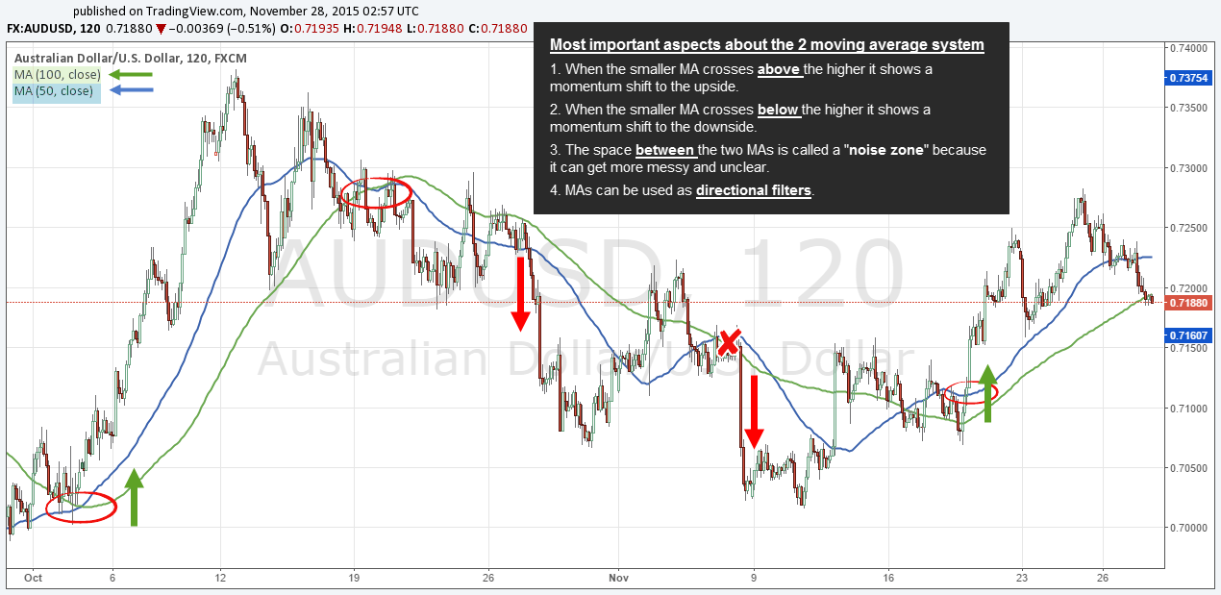](https://www.tradeciety.com/wp-content/uploads/5_MA.png)

* Generally, price above a moving average signals an uptrend [read about [Marty Schwartz’s trading tips](https://www.tradeciety.com/the-11-trading-rules-and-principles-of-a-market-wizard-marty-schwartz/)]
* When the short-term MA crosses above the long-term MA, it signals a bullish trend shift
* When the space between the two MA increases, momentum increases as short-term prices pull away fast from the longer-term average price

**7) RSI**

[The RSI is another indicator](https://www.tradeciety.com/rsi-indicator-tips/) that measures strength. It is similar to the ADX but the RSI is directional. In a healthy uptrend, the RSI makes new highs and higher lows. In a downtrend, the RSI makes new lows and lower highs. In a range environment, the RSI moves sideways between 30 and 70.

The screenshot below shows that the first uptrend was initiated by an RSI divergence (higher lows on the RSI and lower lows on price – a momentum divergence). **During the following uptrend, the RSI made higher highs and higher lows**. After the uptrend, price moved down for a while but not with a lot of strength and the RSI stayed mostly between 30 and 70 (dotted arrow). The next uptrend-phase also started after an RSI divergence and the RSI started making higher lows again until, just recently, another divergence signaled the end of the uptrend.

[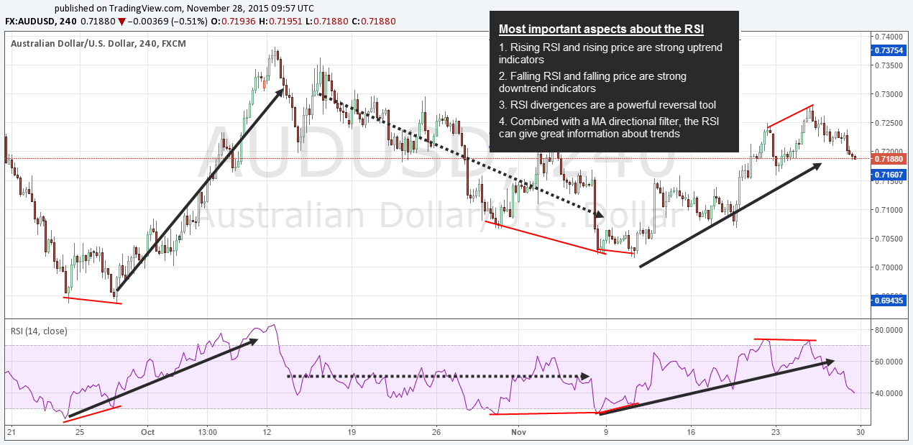](https://www.tradeciety.com/wp-content/uploads/6_RSI2.png)

* During an uptrend, the RSI makes higher highs and higher lows
* A flat RSI ranging between 30 and 70 indicates a lack of momentum
* An RSI divergence shows a momentum divergence and it is often a reversal sign

**8) Bollinger Bands ®**

[Bollinger Bands®](https://www.tradeciety.com/bollinger-bands-explained-step-by-step/) can be combined with other momentum indicators but they are also a great tool for themselves. The screenshot below shows a healthy uptrend and the Bollinger Bands® showed that as **price stayed above the middle Band;** price “grinding” higher between the middle and the outer Band is a typical trend signal.

A trend is usually **broken once price crosses the middle Band**. **A price spike outside the outer Band** which immediately reverses back into the Bollinger Bands® can often signal [a change in trend direction](https://www.tradeciety.com/how-to-trade-volatility-spikes-with-the-bollinger-bands/).

[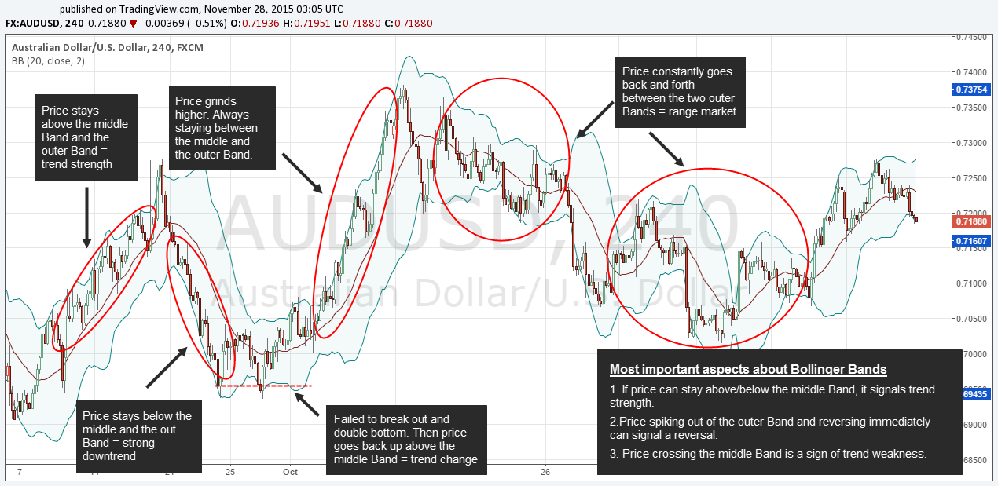](https://www.tradeciety.com/wp-content/uploads/7_BB.png)

* In an uptrend, price moves higher between the middle and the outer band
* A break of the middle band often signals a trend reversal or the lack of momentum
* A price spike through the outer bands and an immediate reversal indicates a sentiment shift

**Knowing the strength of a trend is the backbone of any trading method**

Understanding trend strength and being able to read the balance between bulls and bears is a very important skill every trader has to develop. And although each of the 6 described tools and concepts can be very helpful, you should pick 1-2 to avoid confusion and indicator redundancy.